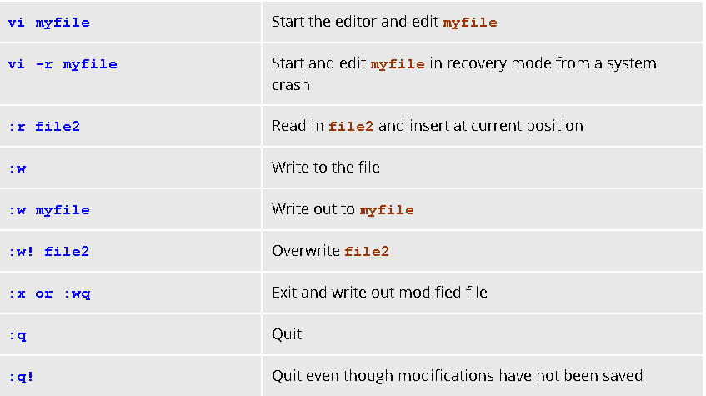

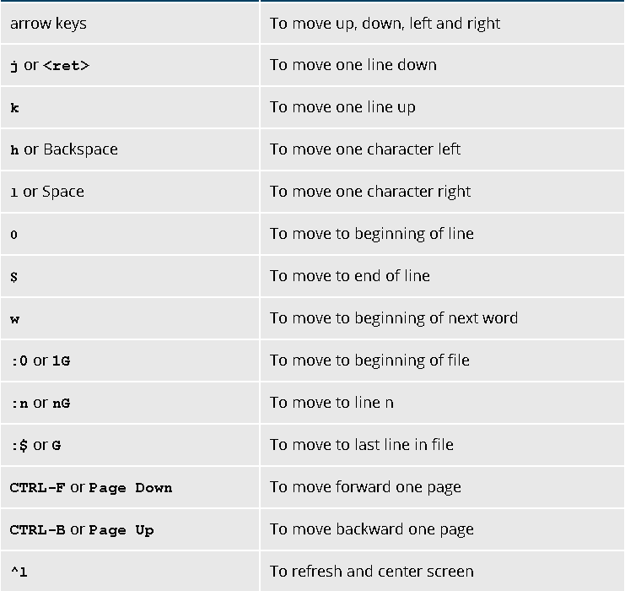

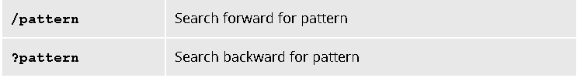

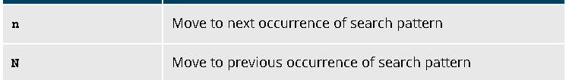

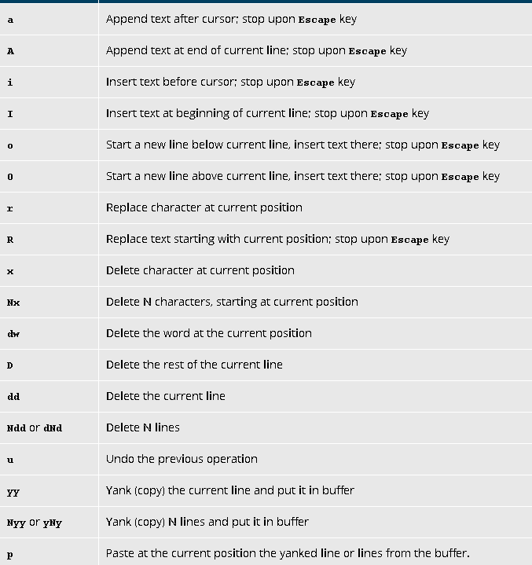

**!**executes a command from within **vi**, such as**: ! wc %**. **wc** (word count), **%** represents the file currently being edited